Pranjal Singh

Stats Library Documentation

This program is a collection of methods used in the second half of probability and applied statistics class. This is a continuation of the previous program that includes all of the formulas used in class. In this half of the course, we covered a few topics that are applicable to the programming library. The methods in this program include hypergeometric distribution, negative binomial distribution, Poisson distribution, and uniform distribution with their expected values and standard deviation. Aside from those two, there is Tchebysheff's theorem as a method as well. With this half of the class, I found the program to be more useful to use in practice than the first half of the class. It helped me cut down on the time of writing things out.

This is the output of the values input into the hypergeometric probability distribution and negative binomial distribution





As you can see, the Poisson distribution methods output the expected values. The Poisson distribution method takes two parameters, X and Lambda. For Poisson, the standard deviation and the predicted values are both equal to Lambda.

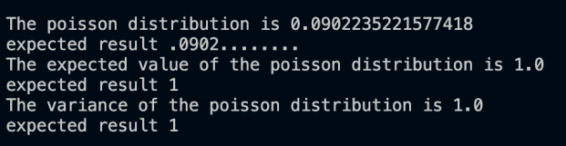

For the uniform distribution, the method takes the two parameters A and B, and outputs the uniform distribution for that. For the purpose of this test, the outputs are all matching the expected values for each problem.

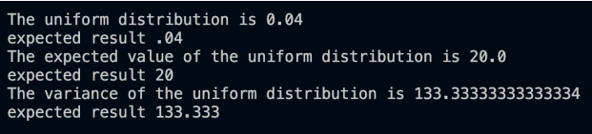

Lastly, we have Tchebysheff's theorem. This just takes the k value and outputs the 1-(1/k^2). This shows the percentage values that fall within a number of standard deviations.

